Appendix

Table of contents

Part I. Mesocosm experiments 2

I.1. Data for the model calibration and evaluation 2

I.1.1. Temperature, photoperiod and food scenarios 2

I.1.2. Characteristics of the founder sticklebacks at the beginning of the experiments 4

I.1.3. Observed stickleback population endpoints 6

I.3. Data for the model development 8

I.3.1. Fecondity of female sticklebacks 8

I.3.2. Number of eggs harvesting by males 8

I.3.3. Daily survival probability of sticklebacks in mesocosms 9

I.3.4. Daily mortality probability and water temperature 10

Part II. DEB-IBM description, sensitivity analyses and calibration 11

II.1. ODD protocol: Model description 11

II.1.1. Design concepts 11

II.1.2. Details 12

II.2. Sensitivity analyses 19

II.2.1. Local sensitivity analysis 19

II.2.2. Morris method 20

II.2.3. Sobol method 22

II.3. Model calibration 26

II.3.1. Calibration method 26

II.3.2. Calibration results 27

II.5. Inter-year dependent parameter 32

II.6. Model evaluation 33

Part III. Model application 35

III.1. Simulation results of toxicant stresses for each endpoint 35

III.2. LOECs for each endpoint and toxicant stress 37

III.2.1. Toxicant impacting the basal mortality: M.n parameter 37

III.2.2. Toxicant impacting the cost of synthesis of a unit of structure: [EG] parameter 38

Part IV. DEB-IBM script 38

References 39

# Part I. Mesocosm experiments

## I.1. Data for the model calibration and evaluation

The DEB-IBM was calibrated with the data from the mesocosm experiments of 2010 and 2011 and was validated with the data from the mesocosm experiments of 2012, 2013 and 2014.

### I.1.1. Temperature, photoperiod and food scenarios

#### I.1.1.1. Model calibration

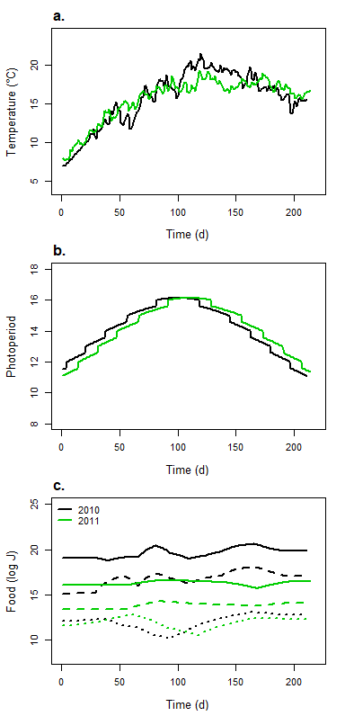

Figure A.1. Temperature (a), photoperiod (b) and food (c) scenarios for 2010 and 2011 mesocosm experiments. For graph c, dotted lines represent the zooplankton energy over time, dashed lines represent energy from macroinvertebrates with a size inferior to 5 mm and full lines represent energy from macroinvertebrates with a size superior to 5 mm

#### I.1.1.2. Model evaluation

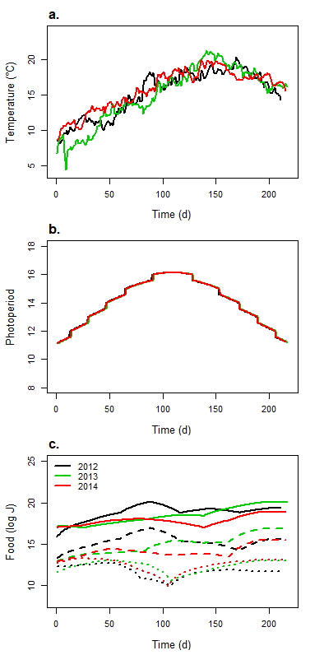

Figure A.2. Temperature (a), photoperiod (b) and food (c) scenarios for 2012, 2013 and 2014 mesocosm experiments. For graph c, dotted lines represent the zooplankton energy over time, dashed lines represent energy from macroinvertebrates with a size inferior to 5 mm and full lines represent energy from macroinvertebrates with a size superior to 5 mm

### I.1.2. Characteristics of the founder sticklebacks at the beginning of the experiments

#### I.1.2.1. Model calibration

Table A.1. Length of the founder sticklebacks when introducing in mesocosms

|  |  |  |  |  |  |  |  |  |  |  |  |  |  |  |  |  |  |  |  |  |  |  |
| --- | --- | --- | --- | --- | --- | --- | --- | --- | --- | --- | --- | --- | --- | --- | --- | --- | --- | --- | --- | --- | --- | --- |
|  | Length of founders (mm) per mesocosm | | | | | | | | | | | | | | | | | | | | | |
|  | 1 | | 2 | | | 3 | | 4 | | 5 | | 6 | | | 7 | | 8 | | 9 | | | |
|  | Females | Males | Females | Males | Females | | Males | Females | Males | Females | Males | | Females | Males | Females | Males | Females | Males | | Females | Males |
| 2010 | 50.86 | 49.11 | 50.32 | 50.05 | 49.3 | | 46.38 | 47.28 | 49.25 | 52.64 | 46.92 | | 47.33 | 49 | 46.87 | 48.68 | 49.37 | 48.11 | | 46.3 | 48.68 |
| 45.61 | 52.62 | 50.69 | 50.96 | 50.67 | | 50.05 | 51.81 | 48.94 | 53.64 | 49.65 | | 49.67 | 48.89 | 47.68 | 48.66 | 48.94 | 47.6 | | 49.28 | 51.15 |
| 49.6 | 52.13 | 46.66 | 48.76 | 46.41 | | 54.56 | 53.16 | 50.46 | 51.91 | 48.69 | | 50.21 | 47.59 | 48.1 | 46.92 | 45 | 48.98 | | 46.49 | 47.4 |
| 45.99 | 45.67 | 48.54 | 49.06 | 53.02 | | 48.37 | 46.83 | 48.8 | 49.94 | 49.72 | | 48.42 | 51.61 | 48.01 | 49.49 | 48.84 | 45.57 | | 48.1 | 51.71 |
| 45.37 | 51.71 | 46.85 | 47.65 | 46.48 | | 48.67 | 47.06 | 45.09 | 47.93 | 50.91 | | 48.95 | 45.95 | 48.1 | 46.33 | 48.25 | 48.54 | | 49.44 | 49 |
| 51.29 | 53.07 | 48.17 | 51.27 | 50.47 | | 47.65 | 51.63 | 51.5 | 50.76 | 45.83 | | 48.93 | 48.61 | 45.76 | 45.81 | 49.31 | 50.49 | | 48.36 | 49.2 |
| 48.25 | 49.92 | 51.98 | 48.5 | 48.17 | | 49.24 | 47.13 | 47.19 | 49.69 | 52.6 | | 46.87 | 48.44 | 46.55 | 51.27 | 48.35 | 49 | | 49.05 | 48.85 |
| 55.13 | 52.47 | 50 | 50.82 | 51.79 | | 47.95 | 51.45 | 50.87 | 53.57 | 50.56 | | 52.69 | 51.68 | 56.58 | 49.2 | 55.9 | 51.83 | | 55.13 | 49.96 |
| 54.57 | 51.16 | 58.16 | 45.41 | 53.16 | | 48.64 | 49.87 | 49 | 52.85 | 48.51 | | 51.63 | 44.12 | 49.98 | 50.67 | 56.44 | 50.76 | | 55.82 | 56 |
| 57.34 | 47.04 | 53.28 | 49.44 | 53.63 | | 47.47 | 55.12 | 49.18 | 55.71 | 45.72 | | 57.16 | 49.17 | 54.49 | 44.89 | 54.29 | 45.42 | | 58.25 | 47.36 |
| 51.75 |  | 52.87 |  | 53.81 | |  | 51.7 |  | 53.7 |  | | 51.14 |  | 51.83 |  | 58.1 |  | | 54.89 |  |
| 56.22 |  | 51.66 |  | 56.77 | |  | 58.79 |  | 54.78 |  | | 55.52 |  | 48.85 |  | 57.94 |  | | 49.42 |  |
| 56.4 |  | 53 |  | 48.86 | |  | 52.28 |  | 51.68 |  | | 55.24 |  | 53.47 |  | 58.04 |  | | 50 |  |
| 54.74 |  | 55.28 |  | 50.91 | |  | 53.53 |  | 52.5 |  | | 52.61 |  | 53.37 |  | 51.3 |  | | 51.86 |  |
| 53.71 |  | 57.34 |  | 50.59 | |  | 51.2 |  | 47.26 |  | | 55.64 |  | 53.25 |  | 52.02 |  | | 55.65 |  |
| 2011 | 45.05 | 43.12 | 42.63 | 43.72 | 40.56 | | 44.11 | 43.45 | 42.38 | 39.82 | 44.21 | | 39.17 | 43.82 | 43.77 | 39.94 | 41.32 | 43.75 | |  |  |
| 44.69 | 45.12 | 42.57 | 39.79 | 39.01 | | 43.38 | 42.8 | 41.94 | 40 | 41.44 | | 45.01 | 43.33 | 44.41 | 44.09 | 42.45 | 44.07 | |  |  |
| 41.12 | 42.3 | 42.02 | 41.26 | 39.01 | | 44.55 | 42.4 | 40.32 | 41.31 | 45.37 | | 42.84 | 44.78 | 41.07 | 42.17 | 46.33 | 41.09 | |  |  |
| 39.56 | 41.23 | 42.64 | 41.28 | 43.75 | | 43.25 | 44.42 | 42.63 | 44.49 | 40.3 | | 43.78 | 45.12 | 40.75 | 44.23 | 41.86 | 41.07 | |  |  |
| 43.54 | 43.84 | 43.47 | 42.54 | 43.76 | | 42.4 | 42.66 | 43.16 | 41.33 | 43.64 | | 42.75 | 43.91 | 43.73 | 43.16 | 40.27 | 40.2 | |  |  |
| 44.65 | 44.15 | 43.45 | 43.51 | 41.12 | | 39.86 | 45.05 | 44.82 | 44.14 | 42.47 | | 42.3 | 44.99 | 45.13 | 41.11 | 44.23 | 39.46 | |  |  |
| 39.66 | 41.37 | 42.54 | 41.29 | 40.04 | | 42.84 | 40.87 | 42.55 | 41.55 | 42.25 | | 41.3 | 45.47 | 44.96 | 43.3 | 44.84 | 44.77 | |  |  |
| 43 | 43.85 | 40.25 | 42.12 | 43.58 | | 41.96 | 42.21 | 44.38 | 42.42 | 40.4 | | 45.06 | 41.67 | 45.05 | 40.24 | 43.68 | 44.38 | |  |  |
| 42.9 | 38.12 | 45.47 | 38.59 | 42.03 | | 35.44 | 40.99 | 34.38 | 41.84 | 35.51 | | 40.68 | 38.54 | 44.19 | 38.84 | 43.63 | 37.28 | |  |  |
| 44.24 | 38.24 | 44.74 | 33.76 | 42.58 | | 39.68 | 42.4 | 33.65 | 44.96 | 38.96 | | 44.32 | 36.58 | 44.85 | 35.07 | 41.98 | 37.48 | |  |  |
| 40.36 |  | 40.22 |  | 41.86 | |  | 43.49 |  | 43.81 |  | | 42.75 |  | 42.42 |  | 44.11 |  | |  |  |
| 43.75 |  | 43.19 |  | 42.61 | |  | 44.77 |  | 42.99 |  | | 43.8 |  | 42.87 |  | 40.3 |  | |  |  |
| 41.93 |  | 41.64 |  | 39.62 | |  | 43.73 |  | 41.59 |  | | 42.91 |  | 42.94 |  | 43.13 |  | |  |  |
| 41.14 |  | 44.39 |  | 41.18 | |  | 39.84 |  | 42.26 |  | | 40.6 |  | 44.08 |  | 39.66 |  | |  |  |
| 41.84 |  | 41.14 |  | 42.79 | |  | 38.54 |  | 39.34 |  | | 42.17 |  | 42.63 |  | 42.51 |  | |  |  |

#### I.1.2.2. Model evaluation

Table A.2. Length of the founder sticklebacks when introducing in mesocosms (2012, 2013 and 2014)

|  |  |  |  |  |  |  |
| --- | --- | --- | --- | --- | --- | --- |
|  | Length of founders (mm) per mesocosms | | | | | |
|  | 1 | | 2 | | 3 | |
|  | Females | Males | Females | Males | Females | Males |
| 2012 | 41.48 | 44.06 | 43.41 | 45.06 | 40.00 | 42.73 |
| 44.16 | 48.65 | 42.54 | 40.41 | 43.71 | 42.83 |
| 42.97 | 47.18 | 41.07 | 44.16 | 41.07 | 42.99 |
| 42.52 | 43.81 | 41.67 | 45.05 | 42.91 | 45.77 |
| 44.05 | 42.67 | 42.11 | 46.7 | 43.43 | 46.33 |
| 43.22 | 42.37 | 43.08 | 42.49 | 41.64 | 40.05 |
| 42.30 | 41.64 | 41.42 | 43.26 | 43.05 | 45.01 |
| 45.00 | 43.91 | 42.46 | 40.52 | 41.55 | 42.69 |
| 44.24 | 43.89 | 44.76 | 43.48 | 43.58 | 44.71 |
| 42.88 | 44.36 | 41.49 | 47.15 | 43.69 | 46.65 |
| 42.41 |  | 44.52 |  | 42.00 |  |
| 42.95 |  | 42.29 |  | 45.19 |  |
| 42.70 |  | 43.59 |  | 44.68 |  |
| 44.91 |  | 43.89 |  | 41.30 |  |
| 44.84 |  | 45.61 |  | 41.93 |  |
| 2013 | 45.10 | 37.30 | 42.25 | 38.65 | 43.25 | 37.49 |
| 42.34 | 43.87 | 42.65 | 41.24 | 41.70 | 40.73 |
| 41.90 | 41.92 | 44.97 | 44.98 | 43.57 | 44.91 |
| 40.93 | 35.33 | 41.64 | 39.98 | 42.12 | 36.72 |
| 44.51 | 37.68 | 42.15 | 38.30 | 40.47 | 37.00 |
| 43.99 | 38.00 | 42.52 | 37.00 | 44.95 | 37.00 |
| 42.40 | 41.00 | 44.24 | 42.00 | 42.60 | 46.00 |
| 43.47 | 42.00 | 43.54 | 43.00 | 41.83 | 42.00 |
| 43.96 | 44.00 | 41.73 | 41.00 | 42.87 | 44.00 |
| 42.48 | 41.50 | 42.84 | 38.00 | 42.19 | 38.00 |
| 42.40 |  | 44.71 |  | 43.47 |  |
| 42.11 |  | 44.92 |  | 41.60 |  |
| 40.28 |  | 44.62 |  | 42.43 |  |
| 44.99 |  | 41.35 |  | 42.96 |  |
| 42.15 |  | 41.7 |  | 41.05 |  |
| 2014 | 45.06 | 43.13 | 44.39 | 43.80 | 43.33 | 42.88 |
| 42.04 | 45.22 | 43.27 | 40.42 | 42.69 | 41.98 |
| 40.59 | 45.06 | 45.48 | 42.61 | 42.09 | 43.88 |
| 41.86 | 43.09 | 41.57 | 40.96 | 43.45 | 41.61 |
| 43.19 | 42.68 | 42.17 | 44.71 | 44.51 | 44.73 |
| 45.65 | 46.78 | 41.53 | 42.11 | 44.37 | 41.81 |
| 41.66 | 42.78 | 42.88 | 42.66 | 44.25 | 43.39 |
| 43.41 | 45.44 | 42.84 | 42.62 | 42.67 | 47.98 |
| 44.72 | 41.98 | 42.77 | 41.96 | 45.27 | 43.53 |
| 43.76 | 44.57 | 41.93 | 43.06 | 42.12 | 42.73 |
| 41.64 |  | 42.72 |  | 41.09 |  |
| 42.33 |  | 41.89 |  | 45.61 |  |
| 42.69 |  | 44.71 |  | 45.33 |  |
| 41.48 |  | 42.80 |  | 43.60 |  |
| 40.77 |  | 41.34 |  | 44.83 |  |

### I.1.3. Observed stickleback population endpoints

#### I.1.3.1. Model calibration

Table A.3. Experimental data from the mesocosm experiments of 2010 and 2011 at the end of the experiments. The estimated value and the confidence interval (quantiles 2.5 and 97.5%) were presented for the median and the coefficient of variation (CV) for each endpoint of both years.

|  |  |  |  |  |  |  |  |  |  |  |  |  |
| --- | --- | --- | --- | --- | --- | --- | --- | --- | --- | --- | --- | --- |
|  |  |  |  | Data per mesocosms | | | | | | | | |
| Year | Endpoint | Median [IC 95%] | CV [IC 95%] | 1 | 2 | 3 | 4 | 5 | 6 | 7 | 8 | 9 | |
| 2010 | N.tot | 862 [772 - 1074] | 0.199 [0.078 - 0.285] | 907 | 814 | 627 | 1074 | 1286 | 772 | 862 | 883 | 788 | |
| N.F.C00 | 10 [8 - 11] | 0.151 [0.070 - 0.213] | 10 | 10 | 11 | 8 | 11 | 10 | 9 | 7 | 12 | |
| L.F.C00 | 61.11 [59.51 - 63.82] | 0.028 [0.017 - 0.035] | 62.71 | 64.28 | 60.27 | 59.51 | 63.82 | 61.11 | 59.44 | 62.68 | 60.79 | |
| CV.F.C00 | 0.052 [0.046 - 0.066] | 0.233 [0.106 - 0.373] | 0.052 | 0.046 | 0.051 | 0.060 | 0.028 | 0.066 | 0.050 | 0.058 | 0.073 | |
| N.M.C00 | 6 [4 - 7] | 0.261 [0.172 - 0.333] | 7 | 4 | 4 | 8 | 4 | 6 | 6 | 6 | 4 | |
| L.M.C00 | 54.50 [53.58 - 55.73] | 0.018 [0.011 - 0.023] | 55.01 | 55.35 | 53.125 | 55.73 | 56.17 | 53.58 | 53.78 | 54.09 | 54.50 | |
| CV.M.C00 | 0.042 [0.020 - 0.059] | 0.542 [0.199 - 0.781] | 0.036 | 0.045 | 0.059 | 0.109 | 0.016 | 0.042 | 0.034 | 0.042 | 0.020 | |
| F.F | 0.197 [0.102 - 0.282] | 0.337 [0.178 - 0.472] | 0.198 | 0.192 | 0.325 | 0.102 | 0.102 | 0.282 | 0.197 | 0.190 | 0.251 | |
| L.F.CXX | 32.75 [32.04 - 33.43] | 0.023 [0.013 - 0.032] | 31.93 | 33.43 | 32.75 | 32.64 | 34.42 | 33.29 | 32.28 | 33.24 | 32.04 | |
| CV.F.CXX | 0.140 [0.121 - 0.166] | 0.116 [0.065 - 0.151] | 0.121 | 0.166 | 0.133 | 0.167 | 0.153 | 0.143 | 0.130 | 0.140 | 0.121 | |
| L.M.CXX | 33.27 [32.60 - 34.43] | 0.023 [0.014 - 0.029] | 34.08 | 33.28 | 33.17 | 32.60 | 34.43 | 33.73 | 32.73 | 34.59 | 32.33 | |
| CV.M.CXX | 0.148 [0.129 - 0.154] | 0.094 [0.048 - 0.132] | 0.151 | 0.146 | 0.133 | 0.154 | 0.171 | 0.152 | 0.129 | 0.148 | 0.124 | |
| F.J | 0.613 [0.495 - 0.780] | 0.197 [0.101 - 0.284] | 0.613 | 0.590 | 0.388 | 0.780 | 0.800 | 0.495 | 0.632 | 0.619 | 0.532 | |
| L.J | 20.61 [20.17 - 21.61] | 0.048 [0.025 - 0.070] | 20.61 | 21.13 | 21.99 | 20.18 | 18.56 | 21.61 | 20.11 | 20.40 | 21.51 | |
| CV.J | 0.109 [0.091 - 0.119] | 0.139 [0.074 - 0.193] | 0.107 | 0.109 | 0.091 | 0.119 | 0.141 | 0.094 | 0.118 | 0.109 | 0.090 | |
| F.M.m | 0.865 [0.817 - 0.891] | 0.043 [0.024 - 0.061] | 0.883 | 0.843 | 0.817 | 0.802 | 0.881 | 0.855 | 0.891 | 0.935 | 0.865 | |
| L.M.m | 35.58 [34.25 - 35.89] | 0.023 [0.012 - 0.031] | 35.89 | 34.82 | 34.85 | 35.58 | 36.13 | 35.67 | 34.25 | 35.84 | 33.55 | |
| CV.M.m | 0.169 [0.153 - 0.188] | 0.115 [0.045 - 0.158] | 0.176 | 0.163 | 0.153 | 0.218 | 0.188 | 0.165 | 0.172 | 0.169 | 0.151 | |
| 2011 | N.tot | 960 [742 - 1040] | 0.160 [0.088 - 0.223] | 830 | 742 | 707 | 975 | 944 | 997 | 1040 | 1190 |  | |
| N.F.C00 | 9.5 [7.5 - 12] | 0.238 [0.125 - 0.312] | 8 | 9 | 7 | 10 | 10 | 7 | 12 | 14 |  | |
| L.F.C00 | 55.27 [53.54 - 56.15] | 0.022 [0.013 - 0.029] | 56.52 | 55.66 | 53.54 | 54.25 | 55.31 | 55.23 | 53.35 | 56.99 |  | |
| CV.F.C00 | 0.062 [0.056 - 0.082] | 0.234 [0.114 - 0.331] | 0.059 | 0.042 | 0.094 | 0.057 | 0.065 | 0.072 | 0.082 | 0.056 |  | |
| N.M.C00 | 6 [4 - 10] | 0.379 [0.202 - 0.519] | 4 | 6 | 5 | 6 | 3 | 10 | 10 | 7 |  | |
| L.M.C00 | 48.74 [47.27 - 49.93] | 0.029 [0.017 - 0.038] | 48.93 | 49.39 | 46.98 | 48.55 | 47.27 | 50.47 | 47.48 | 51.16 |  | |
| CV.M.C00 | 0.056 [0.046 - 0.079] | 0.226 [0.096 - 0.294] | 0.056 | 0.046 | 0.053 | 0.052 | 0.083 | 0.059 | 0.043 | 0.079 |  | |
| F.F | 0.159 [0.141 - 0.210] | 0.177 [0.080 - 0.230] | 0.210 | 0.163 | 0.218 | 0.141 | 0.155 | 0.172 | 0.142 | 0.131 |  | |
| L.F.CXX | 31.66 [31.34 - 32.50] | 0.017 [0.008 - 0.023] | 31.34 | 31.40 | 32.80 | 31.65 | 31.07 | 31.67 | 32.08 | 32.51 |  | |
| CV.F.CXX | 0.135 [0.126 - 0.147] | 0.087 [0.044 - 0.117] | 0.130 | 0.125 | 0.131 | 0.144 | 0.126 | 0.138 | 0.162 | 0.147 |  | |
| L.M.CXX | 33.37 [32.66 - 33.65] | 0.019 [0.010 - 0.028] | 32.66 | 32.69 | 34.44 | 33.35 | 32.19 | 33.54 | 33.39 | 33.65 |  | |
| CV.M.CXX | 0.136 [0.132 - 0.162] | 0.104 [0.064 - 0.127] | 0.124 | 0.133 | 0.132 | 0.138 | 0.132 | 0.166 | 0.162 | 0.158 |  | |
| F.J | 0.685 [0.617 - 0.703] | 0.089 [0.036 - 0.122] | 0.573 | 0.660 | 0.580 | 0.688 | 0.694 | 0.682 | 0.713 | 0.760 |  | |
| L.J | 19.88 [19.56 - 20.30] | 0.020 [0.012 - 0.026] | 20.64 | 20.30 | 19.56 | 20.19 | 19.56 | 19.72 | 20.05 | 19.47 |  | |
| CV.J | 0.145 [0.132 - 0.153] | 0.077 [0.040 - 0.103] | 0.123 | 0.128 | 0.154 | 0.145 | 0.145 | 0.154 | 0.136 | 0.152 |  | |
| F.M.m | 0.909 [0.880 - 0.929] | 0.027 [0.016 - 0.035] | 0.9 | 0.918 | 0.937 | 0.880 | 0.917 | 0.884 | 0.940 | 0.869 |  | |
| L.M.m | 34.85 [33.48 - 35.48] | 0.027 [0.013 - 0.036] | 33.48 | 34.13 | 35.45 | 34.79 | 32.94 | 35.48 | 34.91 | 35.74 |  | |
| CV.M.m | 0.153 [0.142 - 0.177] | 0.119 [0.070 - 0.151] | 0.139 | 0.160 | 0.134 | 0.146 | 0.146 | 0.188 | 0.177 | 0.176 |  | |

#### I.1.3.2. Model calibration

|  |  |  |  |  |
| --- | --- | --- | --- | --- |
| Year | Endpoint | Data per mesocosm | | |
|  |  | 1 | 2 | 3 |
| 2012 | N.tot | 962 | 733 | 1049 |
| N.F.C00 | 8 | 7 | 7 |
| L.F.C00 | 60.24 | 59.87 | 55.59 |
| CV.F.C00 | 0.050 | 0.027 | 0.056 |
| N.M.C00 | 9 | 4 | 5 |
| L.M.C00 | 51.61 | 49.98 | 50.22 |
| CV.M.C00 | 0.055 | 0.064 | 0.057 |
| F.F | 0.108 | 0.194 | 0.092 |
| L.F.CXX | 32.19 | 31.13 | 30.28 |
| CV.F.CXX | 0.152 | 0.103 | 0.121 |
| L.M.CXX | 33.64 | 31.97 | 30.57 |
| CV.M.CXX | 0.165 | 0.120 | 0.114 |
| F.J | 0.785 | 0.619 | 0.810 |
| L.J | 19.94 | 19.93 | 19.46 |
| CV.J | 0.144 | 0.154 | 0.153 |
| F.M.m | 0.860 | 0.872 | 0.939 |
| L.M.m | 36.69 | 33.29 | 31.79 |
| CV.M.m | 0.200 | 0.144 | 0.177 |
| 2013 | N.tot | 1137 | 1019 | 1522 |
| N.F.C00 | 6 | 2 | 10 |
| L.F.C00 | 62.65 | 57.55 | 63.16 |
| CV.F.C00 | 0.041 | 0.092 | 0.066 |
| N.M.C00 | 6 | 3 | 4 |
| L.M.C00 | 54.63 | 50.90 | 56.50 |
| CV.M.C00 | 0.119 | 0.126 | 0.047 |
| F.F | 0.112 | 0.115 | 0.059 |
| L.F.CXX | 30.22 | 29.72 | 28.95 |
| CV.F.CXX | 0.120 | 0.103 | 0.087 |
| L.M.CXX | 30.59 | 30.46 | 30.18 |
| CV.M.CXX | 0.144 | 0.117 | 0.141 |
| F.J | 0.748 | 0.729 | 0.857 |
| L.J | 20.81 | 20.67 | 19.02 |
| CV.J | 0.118 | 0.127 | 0.136 |
| F.M.m | 0.613 | 0.748 | 0.50 |
| L.M.m | 32.46 | 31.65 | 31.82 |
| CV.M.m | 0.216 | 0.154 | 0.219 |
| 2014 | N.tot | 556 | 857 | 949 |
| N.F.C00 | 8 | 11 | 11 |
| L.F.C00 | 63.67 | 63.91 | 63.32 |
| CV.F.C00 | 0.027 | 0.061 | 0.069 |
| N.M.C00 | 8 | 5 | 5 |
| L.M.C00 | 54.28 | 57.20 | 55.58 |
| CV.M.C00 | 0.061 | 0.057 | 0.096 |
| F.F | 0.158 | 0.111 | 0.116 |
| L.F.CXX | 31.36 | 29.75 | 30.83 |
| CV.F.CXX | 0.150 | 0.092 | 0.139 |
| L.M.CXX | 31.56 | 32.61 | 31.21 |
| CV.M.CXX | 0.136 | 0.137 | 0.143 |
| F.J | 0.626 | 0.788 | 0.767 |
| L.J | 20.72 | 20.54 | 19.91 |
| CV.J | 0.148 | 0.130 | 0.160 |
| F.M.m | 0.883 | 0.929 | 0.789 |
| L.M.m | 33.67 | 34.52 | 33.30 |
| CV.M.m | 0.217 | 0.213 | 0.219 |

Table A.4. Experimental data from the mesocosm experiments of 2012 and 2014 at the end of the experiments

## I.3. Data for the model development

### I.3.1. Fecondity of female sticklebacks

Figure A.3. Number of eggs per clutch in function of the female stickleback length. Red points represent the laboratory data and the blue line represents the best fit for the observations (Eq. (A.10)).

### I.3.2. Number of eggs harvesting by males

Figure A.4. Number of harvested eggs in function of the male stickleback length. Red points represent the laboratory data and the blue line represents the best fit for the observations (Eq. (A.11)).

### I.3.3. Daily survival probability of sticklebacks in mesocosms

Figure A.5. Predictions of the daily survival probability in function of the fish length (a) or fish weight (b). Data are from historical mesocosm and laboratory experiments. The points represent the mean daily survival mortality, the dashed blue lines the length interval at which the survival was monitored. Red lines represent the estimation of the daily survival probability in function of the fish length or weight (Eq. (A.15)).

### I.3.4. Daily mortality probability and water temperature

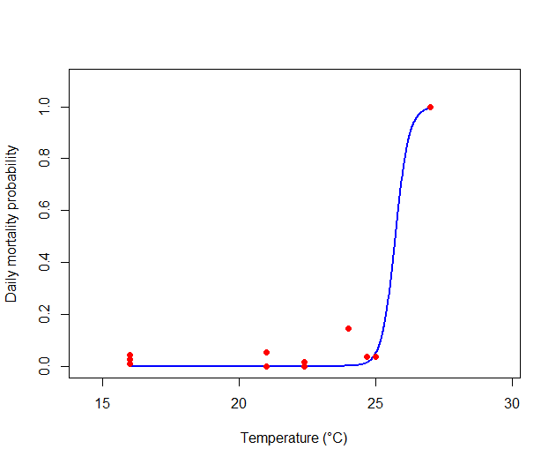

Figure A.6. Predictions of the daily mortality probability in function of the freshwater temperature. Red points represent the observed data from laboratory experiments where juveniles were followed during 4 or 8 days at different water temperature. Blue line represents the estimation of the daily mortality probability in function of the water temperature (Eq. (A.14)).

# Part II. DEB-IBM description, sensitivity analyses and calibration

## II.1. ODD protocol: Model description

The model description follows the ODD protocol for describing individual-based models (Grimm et al. 2006, Grimm et al. 2010). The Purpose, the Entities, state variables, scales and the description of the Process overview and scheduling are given in the main text of the article. Here comes the rest of the ODD protocol.

### II.1.1. Design concepts

**Basic principles.** The model is based on the Dynamic Energy Budget theory (Kooijman 2010) which describes the fluxes of energy within the organism to explain its growth, reproduction and maintenance. Coupling a DEB model and an IBM facilitates the extrapolation of the individual responses to the population level (Beaudouin et al. 2015). The DEB model for the three-spined stickleback was developed by Leloutre et al. (2018) on laboratory experiments and its relevance for predicting physiological processes of founder sticklebacks in mesocosm experiments was assessed by David et al. (2018). The freshwater temperature, photoperiod and food density were integrated in our model as inputs. Specific sub-models were integrated to predict the environment and fish behaviors, including food and reproduction behaviors and mortality (see Appendix Figure A.1).

**Emergence.** The predicted population dynamics emerge from the individuals which interact with each other and their environment.

**Adaptation.** Males can attract the females which have the most eggs in order to maximize their juvenile production.

**Learning and prediction.** Individuals do not learn or predict the future.

**Interaction.** The individuals interact indirectly via the food competition. Moreover, the density-dependant mortality reflects the level of aggressions which is induced by the number of sticklebacks in mesocosms. Males can also compete to get a territory.

The number of harvested eggs depends on the mating interaction between males and females. Males also interact with their eggs and larvae until they leave the nest.

**Sensing.** The establishment of a nest implies that males have a global perception of its environment to assess if enough space was available to build a nest. Globally, individuals indirectly sense the population biomass and total abundance in the mesocosm.

**Stochasticity.** First, the mesocosm is randomly chosen among the number of mesocosms used for a given experiment (ex: mesocosm “4” chosen randomly among the nine mesocosms of the 2010 experiment), then the actual lengths of the founders that were experimentally introduced the chosen mesocosm were setup for the simulation. A second source of stochasticity comes from the inter-individual variability of some DEB parameters (). The “scatter-multiplier” is lognormally distributed with the inter-individual variability parameter (see Table 1) as suggested by Kooijman et al. (1989). In addition, mortality is intrinsically a stochastic process.

Finally, another source of stochasticity comes from the variability inter-mesocosm which affects both the mortality and the food density. The variability inter-mesocosm is driven from a normal distribution with specific coefficient of variation for food and mortality (see Table 1).

**Collectives.** The model does not include collectives.

**Observation.** At the end of the simulation, the predicted endpoints of the DEB-IBM are the same variables monitored in mesocosms. These descriptive variables of the fish population were the population abundance (N.tot), female and juvenile frequencies (F.F and F.J) and the mean lengths and the coefficients of variation of the lengths of five categories of individuals: male and female founders (L.M.C00, L.F.C00, CV.M.C00, CV.F.C00) males and females born in mesocosms (L.M.CXX, L.F.CXX, CV.M.CXX, CV.F.CXX) and juveniles (L.J, CV.J). Finally, the frequency of mature males among the total number of males (F.M.m) was calculated as well as the mean length of mature males and the coefficient of variation of their lengths (L.M.m and CV.M.m). Based on these variables, other variables can be deduced as the male frequency and the sex-ratio were thus not taken into account for the calibration processes.

### II.1.2. Details

#### II.1.2.1. Input data

Temperature and food scenarios were defined from the freshwater temperature measurements (averaged per day and per location of the sensors) and the prey samplings made in mesocosms using the same framework than in David et al. (2018). Briefly, zooplankton and macroinvertebrates were sampled every four weeks in the mesocosms. However, among the possible species, stickleback only predate a subset. The stickleback preys was determined from literature (see David et al. (2018)) and were constituted with higher crustacean (Gammarus and Asellus), a dipteran family (Chironominae) and the zooplankton. Furthermore, the sampling of macroinvertebrates was made by distinguishing two class sizes: inferior and superior to 5 mm. The abundance data have been converted into energy data and have been linearly interpolated between the sampling dates.

To get realistic data of the daylight time at the mesocosm platform and develop the photoperiod scenarios, we used photoperiod data from the Astronomical Applications Department of the U.S. Naval Observatory (http://aa.usno.navy.mil/data/docs/Dur_OneYear.php) with the coordinates 49°16'N and 2°30'E. Temperature, photoperiod and food scenarios were implemented per day.

#### II.1.2.2. Initialization

##### Environment initialization

The photoperiod, temperature and food density are initialized according to the observed scenario of a given experiment. The parameter modelling inter-mesocosm variability is drawn from a standard normal distribution.

##### Founder stickleback initialization

The number of founders is the same than in the mesocosm experiments: 15 females and 10 males. One mesocosm experiment is randomly chosen from the number of mesocosms present at each experiment (9, 8 or 3 depending on the year) in order to initialize the lengths of the simulated founder sticklebacks to the length of the founders introduced in the chosen mesocosm for the simulation.

Each founder sticklebacks are considered mature. The individual DEB parameters and are initialized as well as the DEB variables calculating from those parameters. For the females, the maximum number of eggs () that they can produce in a clutch is initialized, and the number of eggs R that they already have is randomly drawn from a uniform distribution For the males, the number of eggs that they can harvest is initialized (. A time of acclimization (Time.Acc) of their new environment is taken into account and is lognormally distributed with the inter-individual variability parameter.All founders are considered active for the reproduction processes.

##### New born initialization

New individuals born in mesocosm are initialized as juveniles. The individual DEB parameters are initialized as well as the DEB variables calculating from those parameters. Their energy E is initialized at the individual . The length is initialized at the length of sticklebacks at hatchling (). The sex of the juvenile is randomly given with a probability of 0.5 of being a female or male.

#### II.1.2.3. Sub-models

##### Update-environment

**Temperature.** The freshwater temperature is updated at each time step as well as the correcting factor for the DEB parameters. The equation for the temperature correction is from Hovel et al. (2015). Five parameters of the DEB models are corrected with this equation ( and ) as in Leloutre et al. (2018).

**Photoperiod.** The photoperiod is updated at each time step.

**Food density.** The food density in the model is divided into three categories: the zooplankton and the macroinvertebrates inferior and superior to 5 mm as two class sizes were distinguished during the macroinvertebrate samplings. The food density is updated at each time step.

**Movement.** Each individual randomly moves in the mesocosms except for the males. When males have built a nest, they stay near their nest until hatchling (Wootton 1984).

##### DEB models

**Equations.** The DEB model describes the life cycle of the sticklebacks. The physiological processes of the individual (growth, reproduction, maintenance) are described by differential DEB equations given in Leloutre et al. (2018).

**Focus on the functional response .** Sticklebacks have an individual functional response calculated with the following equation from David et al. (2018).

|  |  |
| --- | --- |
|  | Eq. (A.1) |

Where is the scaled food density, the food density (J) one individual have access to at each time step. is the necessary amount of food to be fed ad libitum (J/mm2) which depends on the squared structural length *L* (mm) of the fish. To calculate the food density (J) available for each stickleback, we considered the available energy in the water column around the foraging fish (See David et al. 2018).

At each time step, the food density presents in the water column in which sticklebacks predate is calculating comparing the total surface of the mesocosm and the radius of the water column.

|  |  |
| --- | --- |
|  | Eq. (A.2) |

Where is the surface of the mesocosm (in m²) and the radius (in m) of the water column. The radius is supposed to be dependent on the length of the individual and thus linearly increases with their length until reaching a reference value (given for larger sticklebacks). Indeed, smaller sticklebacks are less explorative compared to larger sticklebacks to reduce the risk of cannibalism (Foster et al. 1988): from the mesocosm observations, fry and small juveniles stay indeed in the vegetation whereas larger fish would have a tendency to be in open water and thus be more explorative.

|  |  |
| --- | --- |
|  | Eq. (A.3) |

Because males are slightly more boldness than females and show greater exploration of their environment in a foraging context (King et al. 2013), the distance they can travel during foraging in increase by the parameter Bold.M (in percentage). Furthermore, among all the prey type monitored in mesocosms, sticklebacks are limited by the size of their mouth to predate prey as shown by Gill and Hart (1994). To assess the food density per individual, we calculated the mouth size from the size of sticklebacks (Nettleship 2011, De Kermoysan 2013) (Eq. (A.4)) to calculate the length of the prey then can predate (Eq. (A.5)) based on the ratio between the mouth and the prey sizes given in Gill and Hart (1994).

|  |  |
| --- | --- |
| and | Eq. (A.4)  Eq. (A.5) |

With and the parameters of the equation and *L* the standard length of the fish (mm), the length of the fish mouth (mm) and the maximal length of the prey (mm) the fish can predate. is the ratio between mouth and prey sizes.

Then, the food density each individual can access to at time *t* is calculated. All individuals can predate zooplankton but the amount of energy from macroinvertebrates they can predate is linearly interpolated from the prey size of the macroinvertebrates and .

|  |  |
| --- | --- |
|  | Eq. (A.6) |

Where is the amount of zooplanckton (in J), and the food density (J) of macroinvertebrates with a length inferior or strictly superior of 5 mm as those two categories of prey were sampled in mesocosms. and are the proportion factors calculated from and the category size of the prey to determine the proportion of food individuals can have from the two class sizes of macroinvertebrates.

The calculation of the food density for the individuals is thus given by:

|  |  |
| --- | --- |
|  | Eq. (A.7) |

Finally, in order to model the competition for food in mesocosms, we calculated a factor of inhibition of growth for the sticklebacks which depends on the produced biomass in mesocosms. The functional response is then multiplied by this factor of inhibition . The competition pressure is supposed to be dependent on the individual weight and higher for juveniles as smaller sticklebacks are less competitive in the mesocosms. Furthermore, the density of juveniles is intense leading to possible intra-cohort competition.

|  |  |
| --- | --- |
| with | Eq. (A.8) |
| And | Eq. (A.9) |

With and the density-dependent parameters for growth, the weight of the fish (expressed in mg/m²), Biomass the produced biomass of sticklebacks in mesocosms (mg/m²). Founder sticklebacks are not supposed to be in competition as there are the most dominant in the mesocosms.

In conclusion, three main processes can affect the functional response first the distance for foraging, then the available quantity of food for each individual and finally the phenomenon of density-dependance.

##### Transition from juvenile to adult

The length threshold between juveniles and adults was fixed at 26 mm in the model because at this length, the sexes of juveniles can be experimentally determined (De Kermoysan 2013). In addition, on the population located at INERIS, no fish were observed mature below 26 mm. Therefore, in the model, juveniles which reach 26 mm are classified in males or females.

##### Puberty process

Juveniles are mature when their cumulated energy is above the threshold of their individual parameter . Then, the state variable *puberty* is activated. Males which have enough energy to bear the reproduction process (determined by R_min) are considered ready for reproduction.

##### Female fecondity

Fecondity (eggs per clutch) is dependent on the stickleback female length (Wootton 1984). In the model, mature females are predicted to produce eggs (variable R in the DEB model) and the size of the clutch ( is determined by Eq. (A.10). When the number of produced eggs has reach the size of the clutch, the female is ready to spawn.

|  |  |
| --- | --- |
|  | Eq. (A.10) |

With and the parameters of the equation and the length of the female in mm. is the length at maturity of the female (mm). Then, only a part of the clutch is spawn in a nest which is determined par Part_Rmax.

Female attributes implied in reproduction are reinitialized after the female had spawn in a nest.

##### Reproductive behavior of the males

The male reproductive behavior is described by 4 sub-parts which correspond to 4 procedures in the Netlogo script.

###### Territory establishment

Stickleback males establish breeding territories (van den Assem 1967, Mori 1993, Candolin and Voigt 2001). In the model, the breeding period is activated when the photoperiod is above the photoperiod threshold for the reproduction processes. Indeed, photoperiod has an impact on the reproduction processes (Borg 1982, Wootton 1984). If so, males can get a territory if they have enough space in the mesocosm (A.Territory.min) and have enough energy to bear the reproduction processes (R_min).

###### Nest building

Males can build a nest if they have a territory. The nest has a daily probability to be destroyed included in the mortality processes (M.nn).

###### Eggs harvesting

If more than one female is ready to spawn, males select the female which have the most eggs to spawn (Wootton 1984). However, a male can receive several clutches from several females in its nest, the maximum number of females which can spawn in a nest is given by the parameter Female.Select.

The maximal number of eggs that a male can harvest depends on the male length (De Kermoysan 2013) and is given by Eq. (A.11).

|  |  |
| --- | --- |
|  | Eq. (A.11) |

With and the parameters of the equation and L the length of the male in mm. is the length at maturity of the male (mm).

When the number of eggs in the nest is above the number of eggs that the male can harvest or that the harvesting time is finished, the male stops to harvest.

###### Hatching

If the time of development of the eggs is reached, the eggs can hatch and the state variables of the fries are initialized. The hatching process is extended over several days as observed in laboratory. The number of eggs to hatch daily is drawn from a uniform distribution taking into account the number of eggs remaining in the nest.

The probability of stopping the reproduction processes for males is calculated by multiplying the number of successful nests that made the male to the parameter Proba.Stop. Then this value is compared to a value of X randomly drawn from a uniform distribution ; if X is lower than the probability then the male stops the reproduction processes. Furthermore, males also stop the reproduction processes when the time of the breeding period is over (determined by Breeding.Period).

##### Mortality

Individual mortality is divided into different parts:

###### *Eggs and larvae mortality*

This mortality is taken into account in the reproduction processes. Each egg and larvae have a probability P.OL of survival. Thus, the number of survival eggs is equaled to the quantity of eggs multiplied by the egg and larvae probability of survival.

###### Daily mortality of the nest.

The daily probability of mortality of the nest depends on the probability of destruction of the nest (M.nn) and the density-dependence of the predators M.nc.

|  |  |
| --- | --- |
|  | Eq. (A.12) |
| With | Eq. (A.13) |

Biomass.P is the biomass of the predators which are suceptible to attack nest, i.e. individuals which are mature (Wootton 1984).

###### *Daily mortality depending of the temperature.*

Mortality of three-spined sticklebacks increases with the water temperature.

|  |  |
| --- | --- |
|  | Eq. (A.14) |

With a.t and b.t the parameters for the calculation of M.t and T the water temperature (in Celsius).

###### Daily mortality of the individuals.

The daily mortality of the individuals depends on the natural mortality and the density-dependence.

The natural mortality is calculated for each individual with an allometric relationship depending on the weight of the individual:

|  |  |
| --- | --- |
|  | Eq. (A.15) |

With Mu and bN the parameters.

Then, the density-dependence is taken into account with the following equation (Hazlerigg et al. 2012).

|  |  |
| --- | --- |
| with | Eq. (A.16) |

With M.n the basal mortality of the individuals, m.dens the density-dependent parameter and N the number of individuals in the population.

Moreover, the males in reproduction have a daily malus of mortality (*Mr*).

Finally, the sum of the probabilities for each individual is computed and an inter-mesocosm variability was added (see Table 1). Then this value is compared to a value of X randomly drawn from a uniform distribution ; if X is inferior to the sum of the probabilities then the individual die.

## II.2. Sensitivity analyses

### II.2.1. Local sensitivity analysis

A local sensitivity analysis was made on the DEB-IBM. The parameter values varied between ± 5% and the global index was calculated according to the method described in Ginot et al. (2006) and Beaudouin et al. (2008). A dummy parameter which has no effect in the model was included to distinct the noise to the real effects of the parameters. As described in Beaudouin et al. (2008), the sensitivity distribution of a parameter which is lower than the 99% upper percentile of the sensitivity distribution of the dummy parameters show that the effects of the parameter on the outputs are not distinguishable from random effects. To avoid correlation between some parameters like a_food and b_food, K_dens and a_Kdens or at and bt, we introduced a ratio between those parameters as well as the second parameter: ab_food (a_food/b_food) and b_food, ab_Kdens (K_dens/a_Kdens) and K_dens or at_bt (at/bt) and bt.

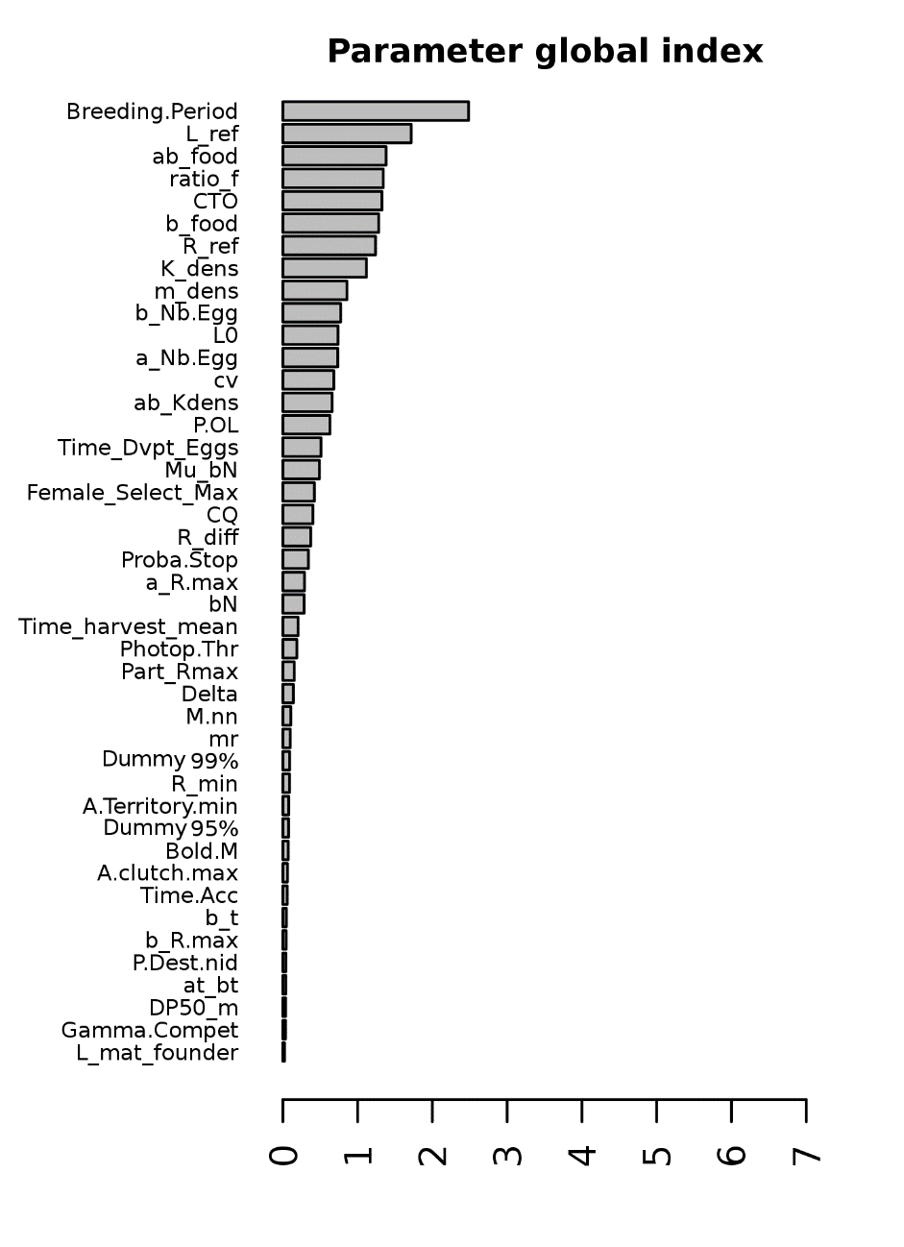

Dummy parameters

Figure A.7. Results of the local sensitivity analysis.

### II.2.2. Morris method

The Morris method is a screening method which highlights the most influential parameters of a model with a low computational cost. It uses the one-step-at-a-time method (OAT), meaning that in each run only one input parameter is given a new value. For more details on the method, see Beaudouin et al. (2015). Here, 80 trajectories were realized using 30 replicates of each set of parameters using the R package “sensitivity” (Iooss et al. 2012).

Table A.5 provides the intervals of confidence used for the Morris sensitivity analyses for each parameter. Results of the sensitivity analysis were given by outputs as the influence of the parameters depend on the studied output (see Figure A.8).

Table A.5. Confidence intervals of the parameters used for the Morris method

|  |  |  |  |  |  |
| --- | --- | --- | --- | --- | --- |
| Parameter | Description | Median | IC 5% | IC 95 % | Unit |
| L0 | Standard length of juveniles at hatching | 5.72 | 4.71 | 6.53 | mm |
| a_R.max | Calculation of the size clutch in function of the female length | 5.37 | 4.52 | 6.23 | 1/mm |
| b_R.max | Calculation of the size clutch in function of the female length | 16.8 | 2.29 | 35.5 | - |
| P.OL | Survival probability of eggs | 0.8982 | 0.709 | 1 | - |
| Female_Select_Max | Maximal number of female to collect its eggs | 4 | 1 | 7 | - |
| A.clutch.max | Maximal duration of keeping eggs for a female | 2 | 1 | 7 | d |
| Proba.Stop | Probability of stopping the reproduction processes for a male | 0.1 | 0.05 | 0.4 | - |
| Part_Rmax | Fraction of eggs to be lay by a female | 0.703 | 0.37 | 1 | - |
| a_Nb.Egg | Parameter for calculatin the maximam number of eggs in a nest in function of the male length | 58.8 | 47.04 | 70.76 | - |
| b_Nb.Egg | Parameter for calculatin the maximam number of eggs in a nest in function of the male length | -437 | -524.4 | -349.6 | - |
| Time_harvest_mean | Harvest mean duration for males (percentage of the cycle) | 12.7 | 10.16 | 15.24 | % |
| Time.Acc | Time for male founder sticklebacks to acclimate themself to their new environment | -7 | -8.4 | -5.6 | degree/d |
| Time_Dvpt_Eggs | Development time for the eggs | 6.9 | 5.1 | 8.7 | degree/d |
| R_min | Minimal energy for males to support the reproduction processes | 1586.565 | 1426.91 | 2099.325 | J |
| L_mat_founder | Standard mature length for founders | 32.55 | 29.295 | 35.805 | mm |
| R_diff | Time between two reproductions | 10 | 5 | 30 | degree/d |
| A.Territory.min | Mimimal territory size for a male | 0.218 | 0.13 | 0.32 | m² |
| Gamma.Compet | Competition parameter for getting a territory | 0.15 | 0.12 | 0.18 | - |
| ab_food | Relationship Length - Mouth size | -0.453 | -0.264 | -1.396 | - |
| b_food | Relationship Length - Mouth size | -0.569 | -0.192 | -0.94 | mm |
| ratio_f | Ratio prey size/mouth size | 0.6 | 0.54 | 0.66 | - |
| K_dens | Parameter of density dependence for the food | 8000 | 6400 | 9600 | mg/m² |
| ab_Kdens | Parameter of density dependence for the food | 0.00005 | 0.00004 | 0.00006 | - |
| R_ref | Reference radius to calculate the radius of the water column | 65.4 | 44.7 | 96.1 | mm |
| L_ref | Reference length to calculate the radius of the water column | 25 | 5.72 | 58.79 | mm |
| Delta | Difference between the optimal and maximal temperature | 2 | 1.8 | 2.2 | degree |
| CTO | Optimal temperature | 23 | 20.7 | 25.3 | degree |
| CQ | Rate at which the function increases over low temperatures | 3 | 2.7 | 3.3 | - |
| m_dens | Parameter for the density dependent mortality | 6.45E-06 | 1.00e-07 | 1.00e-05 | - |
| mr | Malus for the survival of males in reproduction | 0.000856 | 0.0007 | 0.0010 | - |
| Mu_bN | Natural mortality rate at unit weight | -0.0626 | -0.0096 | 0.1117 | - |
| bN | Allometric scaling factor | -0.0516 | -0.147 | -0.058 | 1/d |
| DP50_m | 50% of the density dependence for nest attacks | 4000 | 3242 | 4760 | mg/m² |
| M.nn | Daily mortality of the nests | 0.0191 | 0.0052 | 0.0649 | - |
| at_bt | Parameter to calculate the mortality rate due to the temperature | -0.0388 | -0.0466 | -0.0311 | - |
| b_t | Parameter to calculate the mortality rate due to the temperature | -93.7 | -112.44 | -74.96 | - |
| P.Dest.nid | Probability of destroying a nest after an attack | 0.01 | 0.008 | 0.012 | - |
| Photop.Thr | Minimum day time to start the reproduction | 11.305 | 9.044 | 13.566 | h.min |
| Bold.M | Pourcentage of boldness for males during foraging | 0.17 | 0.1 | 0.2 | - |
| cv | Inter-individual variability | 0.055 | 0.04 | 0.07 | - |
| Breeding.Period | Duration of the breeding period | 130 | 110 | 149 | d |

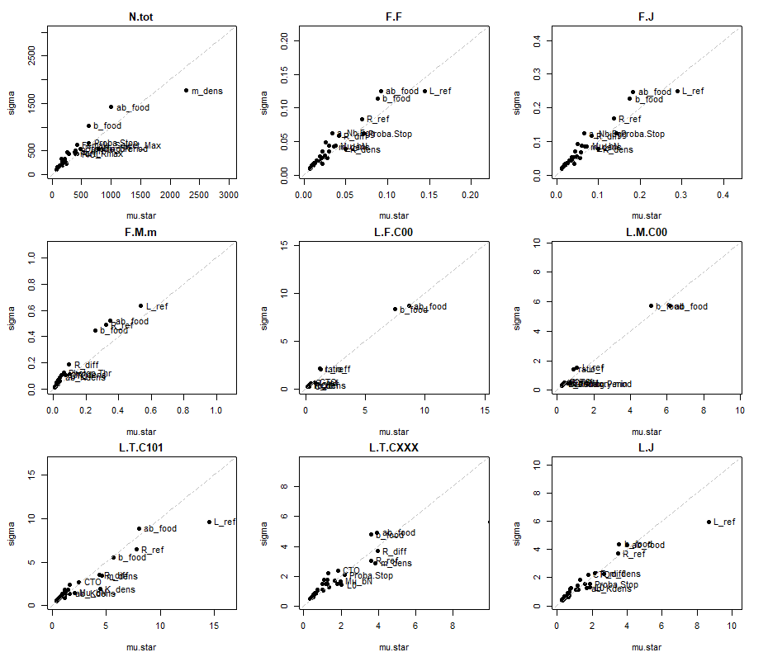

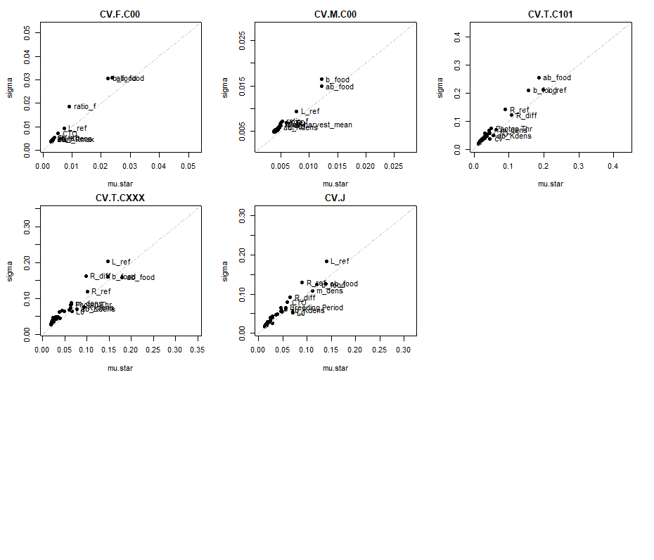**Figure A.8**. Results of the Morris method in function of the parameters outputs. N.tot = Total abundance, F.M, F.F, F.J = Frequency of males, females and juveniles, F.M.m = Frequency of mature males, L.F.C00, L.M.C00, L.T.CXXX, L.T.C101 and L.J = Mean lengths of female and male founders, the sticklebacks born in the mesocosm, the individuals of the first cohort and the juveniles, CV.F.C00, CV.M.C00, CV.T.C101, CV.J = CV of lengths of female and male founders, the individuals of the first cohort and the juveniles. The first 10 parameters with the most effects for each output are shown.

### II.2.3. Sobol method

A sensitivity analysis using the Sobol method was made for the IBM. The variance-based Sobol method is a global sensitivity analysis (Sobol’ et al. 2007, Saltelli et al. 2010) which decomposes the variance of the outputs of the model to attribute it to one or several parameters. To reduce computational costs of the sensitivity analysis, we chose to present the results of the Sobol sensitivity analysis only for the parameters chosen for the calibration and with a variation of ± 10 % of their value. First order and total Sobol’ sensitivity indices were calculated using the R package “sensitivity” (Iooss et al. 2012) as well as their 95% confidence intervals. The results were given in function on the studied outputs (Figure A.9).

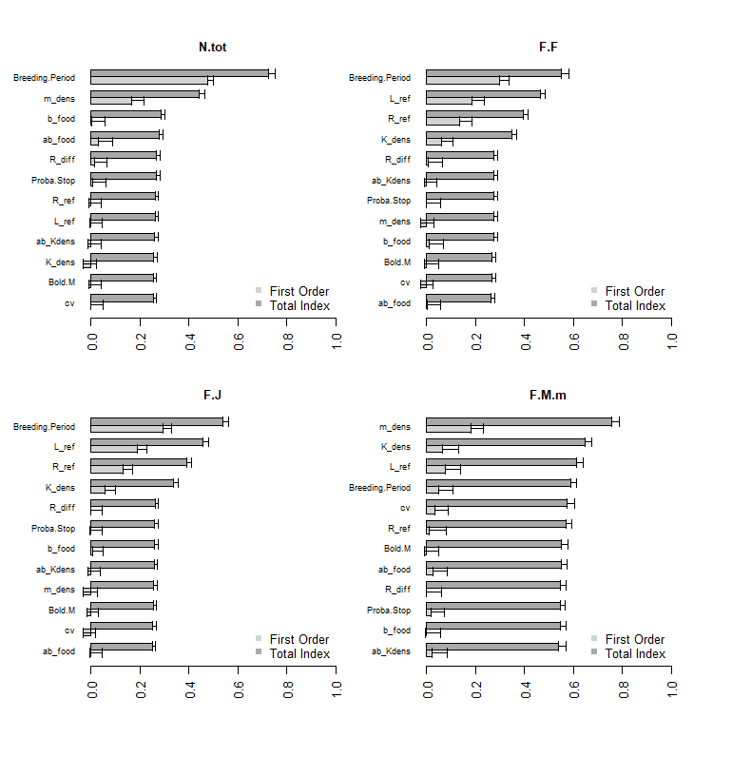

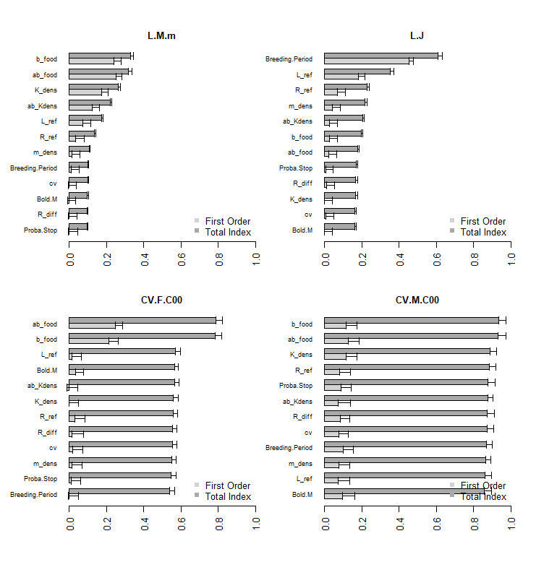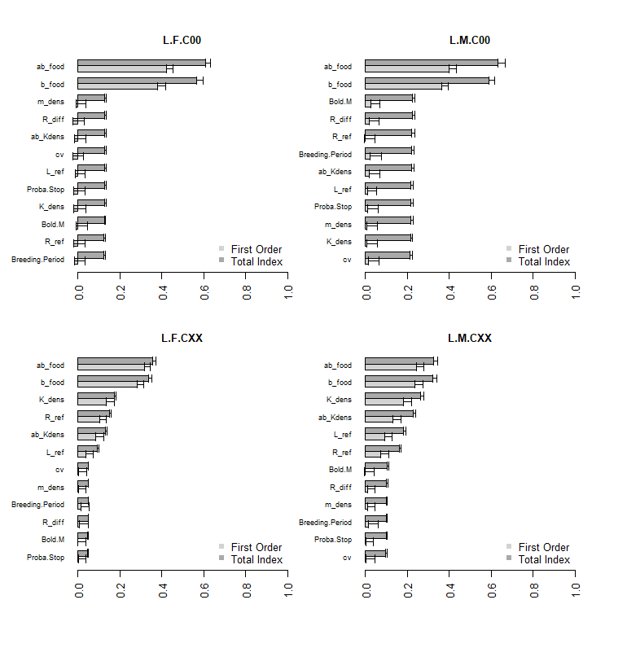



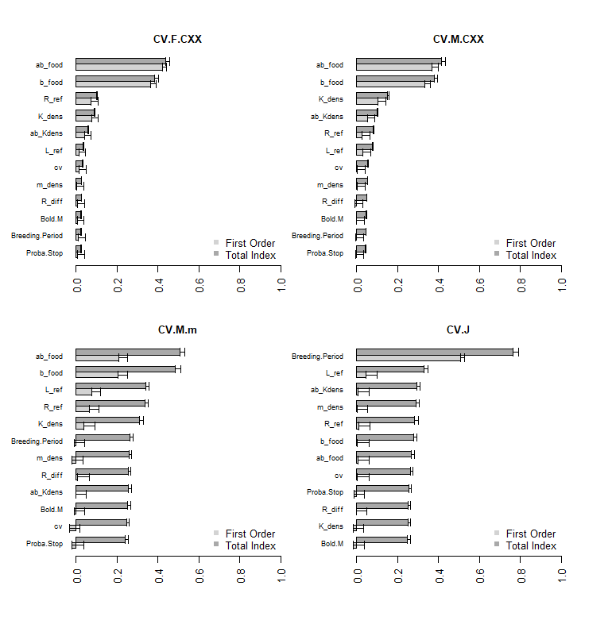

Figure A.9. Results of the sensitivity analysis using the variance-based Sobol’ method for the different population endpoints. The first order and total index are represented as well as their confidence interval. To avoid correlation between some parameters, a ratio between some parameters were used for the sensitivity analysis (ab_food for a_food/b_food and ab_Kdens for K_dens/a_Kdens corresponding respectively to the sensitivity analysis of a_food and a_Kdens).

## II.3. Model calibration

### II.3.1. Calibration method

Calibration of the DEB model had already been performed with laboratory experiments in David et al. (2018). The values and the description of the DEB parameters are given in the following table.

Table A.6. Values and descriptions of the DEB parameters.

|  |  |  |  |
| --- | --- | --- | --- |
| Parameter | Value | Unit | Definition |
|  | 0.250 | - | Shape coefficient |
|  | 5.61 | J | Initial reserve |
|  | 1.33 | J | Cumulated energy invested in maturity at birth |
|  | 375 | J | Cumulated energy invested in maturity at puberty |
|  | 2.42 | J/mm²/d | Maximum surface area specific assimilation rate |
|  | 1.33 | mm/d | Energy conductance |
| κ | 0.757 | - | Specific fraction of energy mobilized from energy from reserved allocated to growth and somatic maintenance |
| α | 0.111 | - | Fraction subtracted from κ to obtain κ in males after maturity |
|  | 0.563 | mm | Size of primordial cell in physical length |
|  | 0.111 | J/mm3/d | Volume specific somatic maintenance costs |
|  | 1.10 | J/mm3 | Cost of synthesis of a unit of structure |
|  | 0.003 | /d | Maturity maintenance rate |
|  | 0.978 | - | Reproduction efficiency |
| φ | 15.31 | J/mm² | Proportional factor to be fed ad libitum for a given day |
|  | 25 | °C | Water temperature above which consumption ceases |
|  | 3 | - | Rate at which the function increases over low temperatures |
|  | 23 | °C | Optimal water temperature |

Calibration of the population model was done using a genetic algorithm available within the software BehaviorSearch (Grimm and Railsback 2005). The distance to minimize was the weighted sum of least squares (WLS) between the predictions and the observations of the endpoints of the population (Eq. 1).

The parameters for the generic algorithm were 0.01, 100, 0.7, 3 respectively for the mutation rate, the population size, the crossover rate and the tournament size. The population model was chosen to be generational. For each set of parameters, the WLS was averaged on 30 simulations and when the generic algorithm found a better solution, the WLS was checked on 100 simulations to avoid false better solutions. The prior and posteriors of the parameters are given in Table A.6.

To avoid correlation between some parameters like a_food and b_food or K_dens and a_Kdens, we calibrated a ratio between those parameters as well as the second parameter: ab_food (a_food/b_food) and b_food, ab_Kdens (K_dens/a_Kdens) and K_dens.

Furthermore, one DEB parameter linked to the stickleback maturity () was re-calibrated on maturity data of males in mesocosms. Calibration of the CVs of the food scenarios and the mortality was also made minimizing the weighted sum of least squares (WLS) between the predictions (CV of the outputs calculated on 100 simulations) and the observations of the CV of the outputs.

Table A.7. Prior, posterior values and parameter spaces of the calibrated parameters

|  |  |  |  |  |
| --- | --- | --- | --- | --- |
| Parameter | Description | Posterior | Prior | Parameter spaces |
| m_dens | Parameter for the density dependent mortality | 8.60E-06 | 0.000106 | [1.10-4; 3.66.10-4] |
| R_diff | Time between two reproductions | 11.14 | 3 | [0 ; 20] |
| Proba.Stop | Probability of stopping the reproduction processes for a male | 0.09 | 0.33 | [0 ; 0.5] |
| Breeding.Period | Duration of the breeding period | 117.23 | 130 | [0 ; 200] |
| R_ref | Reference radius to calculate the radius of the water column | 57.60 | 65.40 | [44.7 ; 96.1] |
| L_ref | Reference length to calculate the radius of the water column | 23.54 | 46.38 | [5.72 ; 56.62] |
| K_dens | Parameter of density dependence for the food | 8702.16 | 10000 | [5000 ; 15000] |
| a_Kdens | Parameter of density dependence for the food | 0.436 | 0.2 | [0.1 ; 0.5] |
| a_food | Relationship Length - Mouth size | 0.297 | 0.258 | [0.248 ; 0.268] |
| b_food | Relationship Length - Mouth size | - 0.743 | - 0.568 | [-0.94 ; -0.192] |
| Bold.M | Pourcentage of boldness for males during foraging | 0.17 | 0.1 | [ 0 ; 0.3 ] |
| cv | Inter-individual variability | 0.061 | 0.055 | [ 0.044 ; 0.066 ] |
| Ehp | Energy at puberty (J) | 374.79 | 441.547 | [ 300 ; 450 ] |
| CV.c_M | Coefficient of variation of the mortality (inter-mesocosm variability) | 23.92 | 20 | [ 10 ; 30 ] |
| CV.c_F | Coefficient of variation of the food (inter-mesocosm variability) | 14.94 | 20 | [ 10 ; 30 ] |

### II.3.2. Calibration results

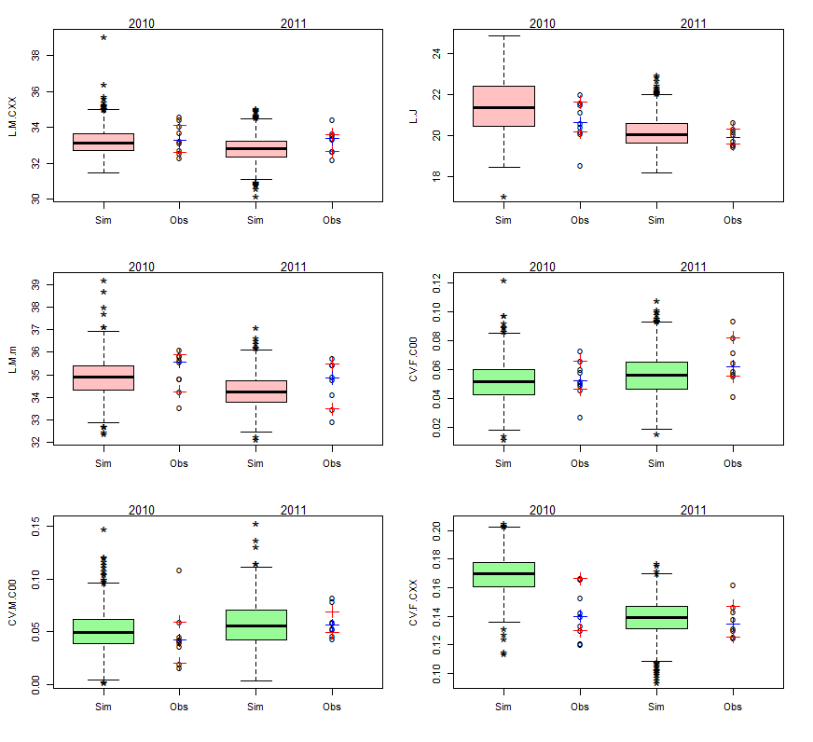



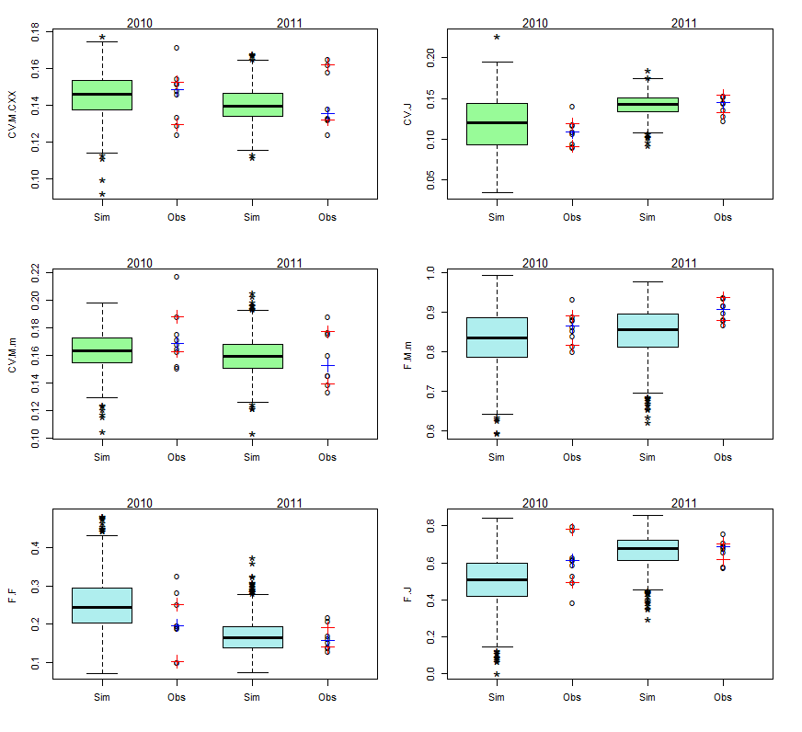

Figure A.10. Results of the calibration for 2010 and 2011 for each population endpoint. Grey boxplots represent the model simulations for the total abundance and number of female and male founders at the end of the experiments. Pink and green boxplots represent respectively the mean lengths and the CV of the lengths of the different categories of individuals. Blue boxplots represent the frequencies of mature males, female and juveniles. The points represent the observations of the descriptive variables of the populations. Blue crosses represent the medians of the observations and red crosses their 95 % confidence interval.

*Predictions of the length frequency*

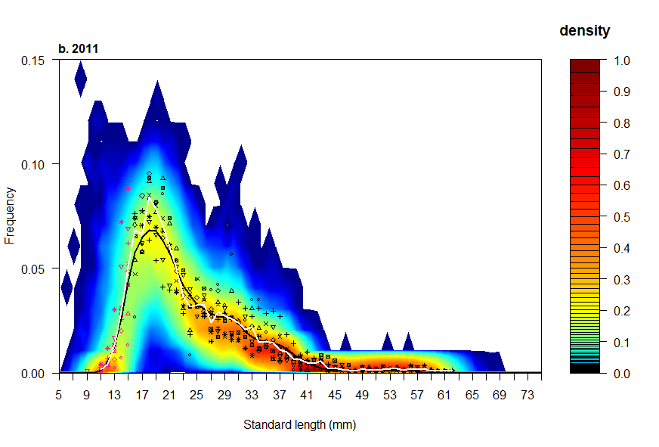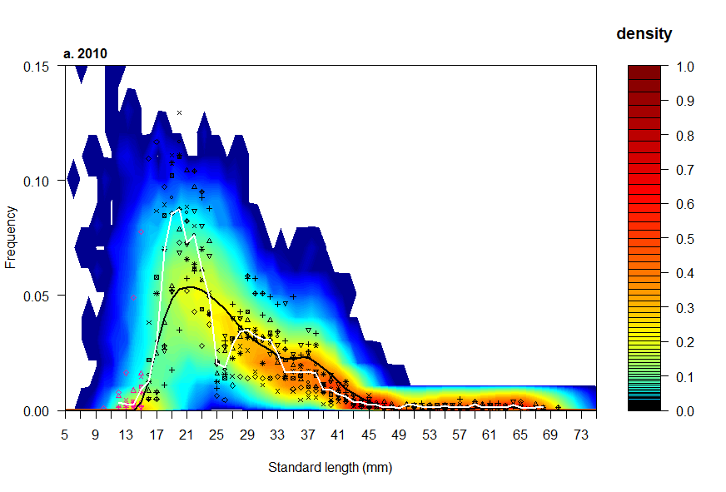

Figure A.11. Probabilistic distributions of the length frequency predicted by the model length compared to frequency distributions observed in the mesocosms of 2010 (a) and 2011 (b). Different point types represent the length frequency distributions of the different observed populations (9 and 8 populations in 2010 and 2011 respectively). Red points correspond to the class size that were excluded from the calibration process (individuals with a length smaller than 15 mm). Full black and white lines represent the median length frequency distributions of the simulated and observed populations respectively. Color level represents the frequency of simulated populations (n = 1000) having a given percentage of individuals for a given class length. Frequency inferior to < 1e-04 are represented in white.

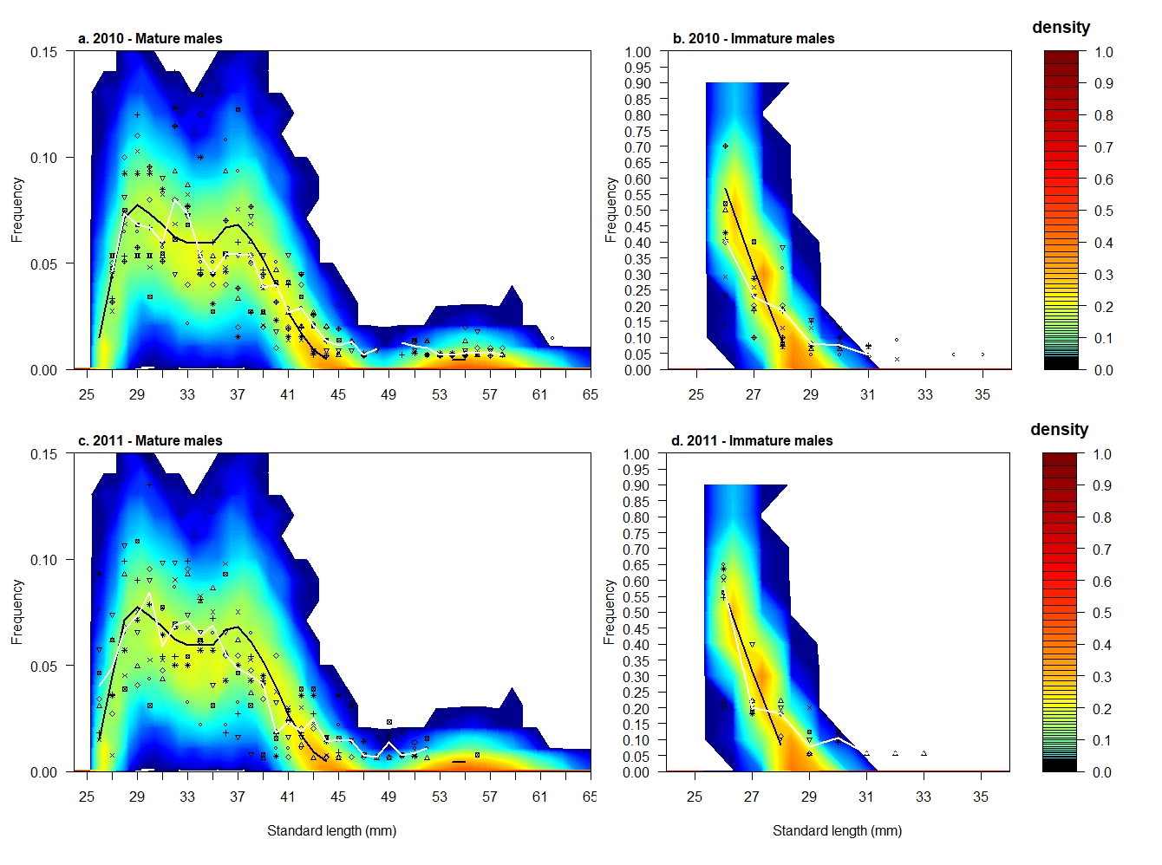*Predictions of the length frequency of mature males*

Figure A.12. Probabilistic distributions of the length frequency of mature (a,c) and immature (b,d) males predicted by the model compared to frequency distributions observed in the mesocosms of 2010 (a,b) and 2011 (c,d). Different point types represent the length frequency distributions of the different observed populations (9 and 8 populations in 2010 and 2011 respectively). Full black and white lines represent the median length frequency distributions of the simulations and observations respectively. Color level represents the frequency of simulations (n = 1000) having a given percentage of individuals for a given class length. Frequency inferior to < 1e-04 are represented in white.

## II.5. Inter-year dependent parameter

A clear shift on the observed frequencies was found between the years of experiments 2010 and 2011 used for the calibration and the years of experiments 2012, 2013 and 2014 used for the validation. Indeed, as seen on the following graph, the fish in the first cohort born in mesocosms had a lower length in 2012, 2013 and 2014 than in 2010 and 2011 (between 30 and 40 mm on the graph). Indeed, the mean lengths of the males and females were 33.17 mm and 32.60 mm for 2010 and 2011 respectively. the mean lengths of the males and females were 31.63 for 2012, 30.02 mm for 2013 and 31.22 mm 2014 respectively. However, this could not be explained by the temperature and food scenarios which were similar of the ones from 2010 and 2011.

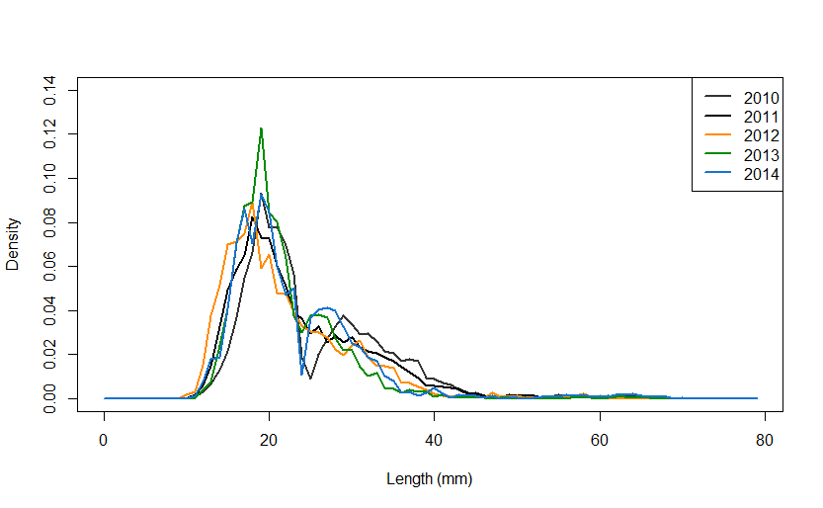

Figure A.13. Mean observed length frequencies for 2010 and 2011 (years of calibration) and 2012, 2013 and 2014 (years of validation).

To take into account the shift on the observed length frequencies, we introduced an inter-year dependent variation of the K_dens parameter responsible of the density-dependent growth and thus of the interactions between the fish and its environment. We did not change the DEB parameters for growth as this acclimatization of the fish to its environment is supposed to be reversible if the fish is isolated with unlimited food and an optimal temperature.

## II.6. Model evaluation

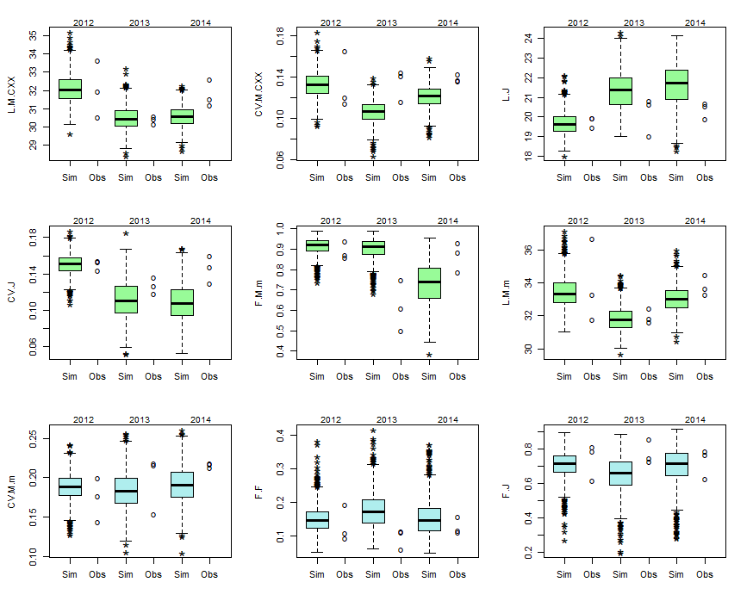Figure A.14. Model predictions of the DEB-IBMs for 2012, 2013 and 2014 for each population endpoints. Grey boxplots represent the model simulations for the total abundance and number of female and male founders at the end of the experiments. Pink and green boxplots represent respectively the mean lengths and the CV of the lengths of the different categories of individuals. Blue boxplots represent the frequencies of mature males, female and juveniles. The points represent the observations of the descriptive variables of the populations.

# Part III. Model application

## III.1. Simulation results of toxicant stresses for each endpoint

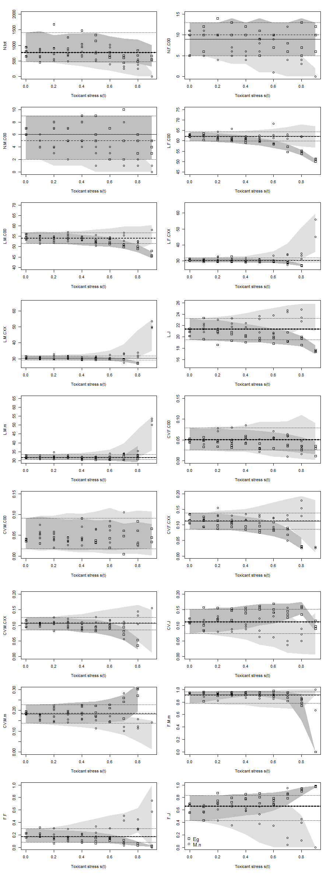

**Figure A.15.** Effects of hypothetical toxicants with the two different tested modes of action and with 3 simulations.

* Circles represent a given mesocosm experiment (3 populations per concentration) with the toxicant affecting the basal mortality and squares represent a given mesocosm experiment (3 populations per concentration) with the toxicant affecting the cost of synthesis of a unit of structure.
* Light grey zone represents the 95 % prediction interval (1000 simulations) of the endpoints with the toxicant affecting the basal mortality and dark grey zone represent the one from the toxicant affecting the cost of synthesis of a unit of structure.
* Dashed grey lines represent the 95 % prediction interval of the medians of the simulations in control conditions (1000 simulations) and dotted grey lines represent the 95 % prediction interval of the endpoints of the simulations in control conditions.

## III.2. LOECs for each endpoint and toxicant stress

### III.2.1. Toxicant impacting the basal mortality: M.n parameter

**Figure A.16.** Comparison of the LOEC distributions calculated for the population endpoints having a toxicant stress impacting the basal mortality. In yellow, the control was constituted by the three replicates available with mesocosm experiment design. In blue, the distribution of the control endpoints was estimated by the model simulations (1000 simulations).

### III.2.2. Toxicant impacting the cost of synthesis of a unit of structure: [EG] parameter

**Figure A.17.** Comparison of the LOEC distributions calculated for the population endpoints having a toxicant stress impacting the basal mortality. In yellow, the control was constituted by the three replicates available with mesocosm experiment design. In blue, distribution of the control endpoints was estimated by the model simulations (1000 simulations).

# Part IV. DEB-IBM script

See additional files:

* The DEB-IBM Netlogo file
* The input files:
  + Input2010.txt
  + Input2011.txt
  + Input2012.txt
  + Input2013.txt
  + Input2014.txt

# References

Beaudouin, R., Goussen, B., Piccini, B., Augustine, S., Devillers, J., Brion, F. and Pery, A. R. (2015). An individual-based model of zebrafish population dynamics accounting for energy dynamics. *PLoS One*, 10, e0125841. doi: 10.1371/journal.pone.0125841.

Beaudouin, R., Monod, G. and Ginot, V. (2008). Selecting parameters for calibration via sensitivity analysis: An individual-based model of mosquitofish population dynamics. *Ecological Modelling*, 218, 29-48. doi: <https://doi.org/10.1016/j.ecolmodel.2008.06.033>.

Borg, B. (1982). Seasonal effects of photoperiod and temperature on spermatogenesis and male secondary sexual characters in the three-spined stickleback, Gasterosteus aculeatus L. *Canadian Journal Of Zoology*, 60, 3377-3386. doi: 10.1139/z82-427.

Candolin, U. and Voigt, H.-R. (2001). Correlation between male size and territory quality: consequence of male competition or predation susceptibility? *Oikos*, 95, 225-230. doi: 10.1034/j.1600-0706.2001.950204.x.

David, V., Goussen, B., Tebby, C., Joachim, S., Porcher, J.-M. and Beaudouin, R. (2018). Modelling historical mesocosm data: Application of a fish bioenergetics model in semi-natural conditions. *Ecology of Freshwater Fish*, 0. doi: 10.1111/eff.12418.

De Kermoysan, G. (2013). Caractérisation de la dynamique de population de l'épinoche à trois épines, Gasterosteus aculeatus, dans un mésocosme lotique : Application à l'évaluation des effets du bisphénol A dans un contexte écosystémique., AgroParisTeach.

Foster, S. A., Garcia, V. B. and Town, M. Y. (1988). Cannibalism as the cause of an ontogenetic shift in habitat use by fry of the threespine stickleback. *Oecologia*, 74, 577-585. doi: 10.1007/bf00380056.

Gill, A. B. and Hart, P. J. B. (1994). Feeding behaviour and prey choice of the threespine stickleback, the interacting effects of prey size, fish size and stomach full. *Animal Behaviour*, 47.

Ginot, V., Gaba, S., Beaudouin, R., Aries, F. and Monod, H. (2006). Combined use of local and ANOVA-based global sensitivity analyses for the investigation of a stochastic dynamic model: Application to the case study of an individual-based model of a fish population. *Ecological Modelling*, 193, 479-491. doi: 10.1016/j.ecolmodel.2005.08.025.

Grimm, V., Berger, U., Bastiansen, F., Eliassen, S., Ginot, V., Giske, J., Goss-Custard, J., Grand, T., Heinz, S. K., Huse, G., Huth, A., Jepsen, J. U., Jørgensen, C., Mooij, W. M., Müller, B., Pe’er, G., Piou, C., Railsback, S. F., Robbins, A. M., Robbins, M. M., Rossmanith, E., Rüger, N., Strand, E., Souissi, S., Stillman, R. A., Vabø, R., Visser, U. and DeAngelis, D. L. (2006). A standard protocol for describing individual-based and agent-based models. *Ecological Modelling*, 198, 115-126. doi: 10.1016/j.ecolmodel.2006.04.023.

Grimm, V., Berger, U., DeAngelis, D. L., Polhill, J. G., Giske, J. and Railsback, S. F. (2010). The ODD protocol A review and first update. *Ecological Modelling*, 221, 2760-2768. doi: 10.1016/j.ecolmodel.2010.08.019.

Grimm, V. and Railsback, S. F. (2005). *Individual-based Modeling and Ecology*. New Jersey.

Hazlerigg, C. R., Lorenzen, K., Thorbek, P., Wheeler, J. R. and Tyler, C. R. (2012). Density-dependent processes in the life history of fishes: evidence from laboratory populations of zebrafish Danio rerio. *PLoS One*, 7, e37550. doi: 10.1371/journal.pone.0037550.

Hovel, R. A., Beauchamp, D. A., Hansen, A. G. and Sorel, M. H. (2015). Development of a Bioenergetics Model for the Threespine Stickleback. *Transactions of the American Fisheries Society*, 144, 1311-1321. doi: 10.1080/00028487.2015.1079554.

Iooss, B., Janon, A. and Pujol, G. (2012). Global Sensitivity Analysis of Model Outputs: R package ‘sensitivity’.

King, A. J., Fürtbauer, I., Mamuneas, D., James, C. and Manica, A. (2013). Sex-Differences and Temporal Consistency in Stickleback Fish Boldness. *PLoS One*, 8, e81116. doi: 10.1371/journal.pone.0081116.

Kooijman, S. A. L. M., Van Der Hoeven, N. and Van Der Werf, D. C. (1989). Population Consequences of a Physiological Model for Individuals. *Functional Ecology*, 3, 325-336. doi: 10.2307/2389373.

Leloutre, C., Péry, A. R. R., Porcher, J.-M. and Beaudouin, R. (2018). A bioenergetics model of the entire life cycle of the three-spined stickleback, gasterosteus aculeatus. *Ecology of Freshwater Fish*, 27, 116-127. doi: 10.1111/eff.12329.

Mori, S. (1993). The Breeding System of the 3-Spined Stickleback, Gasterosteus-Aculeatus (Forma-Leiura) with Reference to Spatial and Temporal Patterns of Nesting Activity. *Behaviour*, 126, 97-124. doi: 10.1163/156853993x00362.

Nettleship, S. (2011). The impacts of river impoundments on the biology of the three-spined stickleback, Gasterosteus aculeatus, Leicester.

Saltelli, A., Annoni, P., Azzini, I., Campolongo, F., Ratto, M. and Tarantola, S. (2010). Variance based sensitivity analysis of model output. Design and estimator for the total sensitivity index. *Computer Physics Communications*, 181, 259-270. doi: 10.1016/j.cpc.2009.09.018.

Sobol’, I. M., Tarantola, S., Gatelli, D., Kucherenko, S. S. and Mauntz, W. (2007). Estimating the approximation error when fixing unessential factors in global sensitivity analysis. *Reliability Engineering & System Safety*, 92, 957-960. doi: 10.1016/j.ress.2006.07.001.

van den Assem, J. (1967). Territory in the Three-Spined Stickleback Gasterosteus aculeatus L.: An Experimental Study in Intra-Specific Competition. *Behaviour. Supplement*, III-164.

Wootton, R. J. (1984). *A Functional Biology of Sticklebacks*. University of Sheffield, England.